

|  |
| --- |
| **Instructor Name**  Mr. Umer Farooq |
| **Lab Engineer**:  MS Qandil Fatima |
| **Student Name**: |

  HIDAYAT ULLAH

|  |
| --- |
| **Department**:        BS-AI (24) |
| **Lab Number:** Lab # 01 |
| **Registration No:** B24F0050AI099 |

**ICT LAB**

**Lab Report 1**

**Re-Installation Of Window**

**WINDOW:**

Windows is an operating system (OS) developed by Microsoft, designed to provide a

graphical user interface (GUI) for interacting with a computer. It simplifies the way users

manage files, programs, and system settings by using windows, icons, and menus, hence the name "Windows."

# ROLE:

* User Interface: Windows provides an easy-to-use graphical interface that allows users to interact with the computer without needing to understand complex commands.
* Platform for Software: It serves as the primary platform for running applications and software, supporting a vast ecosystem of programs used for work, gaming,

productivity, education, etc.

* System Management: Windows manages hardware resources like CPU, memory, storage, and devices. It ensures efficient operation and handles system tasks like updates, security, and user account management.
* Connectivity: It facilitates internet and network connections, allowing users to browse the web, use cloud services, and connect to other devices.
* Security: Windows includes built-in features like firewalls, antivirus protection, and encryption to keep systems secure from malware, viruses, and cyber-attacks.

# IMPORTANCE:

* Widespread Adoption: Windows is one of the most widely used operating systems worldwide, making it a standard platform for personal, business, and educational purposes.
* Software Compatibility: A vast majority of commercial and open-source software is designed to be compatible with Windows, making it a key system for both developers and users.
* Enterprise Use: Windows is heavily used in enterprise environments due to its support for business software, security management, and productivity tools like Microsoft

Office.

* User-Friendly: Its intuitive GUI makes it accessible to users of all skill levels, from beginners to advanced users.
* Innovation and Updates: With regular updates, Windows continues to evolve by adding new features, improving security, and supporting the latest hardware and software advancements.

# RE-INSTLATION OF WINDOW :

## Initiate the Setup

Start by inserting your Windows installation media (USB or DVD), or use the "Update & Security" option in Windows settings to reinstall.

Restart your computer and choose to boot from the installation media.

## Starting the Update

The screen will display "Working on updates 0%."

Don’t turn off your PC. The process will take a while, and your computer will restart several times.

## Windows 10 Installation Begins

The installation process will begin, and you’ll see a progress bar, such as "21% complete." Let the process continue on its own. Your PC will automatically restart during installation.

## Installation Confirmation

Before proceeding, you will see a summary of your choices:

Install Windows 10 Pro.

Keep personal files and apps (you can also change these settings if needed). Once confirmed, click Install to move forward with the installation.

## Downloading Windows Setup Files

Your system will start downloading the necessary Windows 10 setup files.

You can track the progress (e.g., 34% complete), and during this time, you can still use your PC as normal.

## Completing the Installation

Once all files are downloaded, the PC will restart again and finish installing Windows 10. Follow the prompts to finalize setup, such as choosing preferences and settings.

STEP # 1

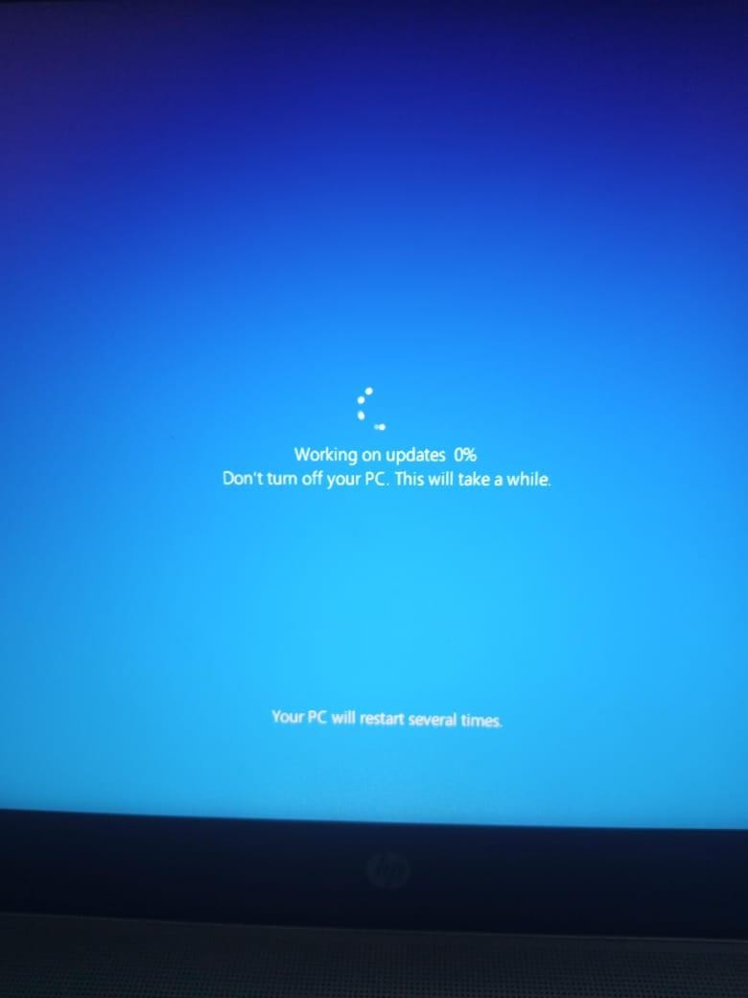

* + This marks the start of the Windows update process.
  + There's nothing for you to do at this point—just let it proceed and ensure the computer stays powered on.

# STEP # 2

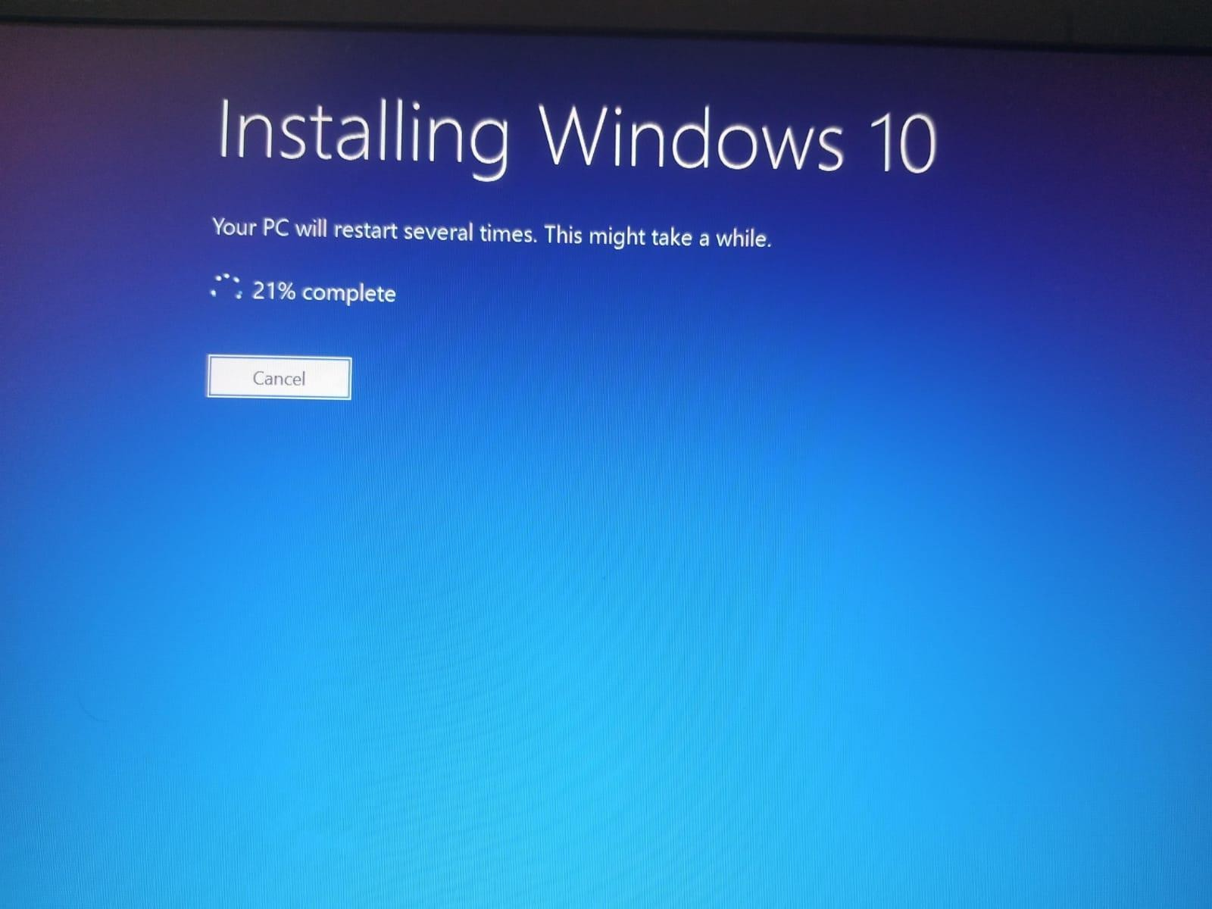

* + A progress bar will appear, indicating that the PC will restart multiple times. There's no need for you to do anything right now.
  + At this stage, simply wait for the installation to move forward. It may take a while, so stay patient.

# STEP # 3

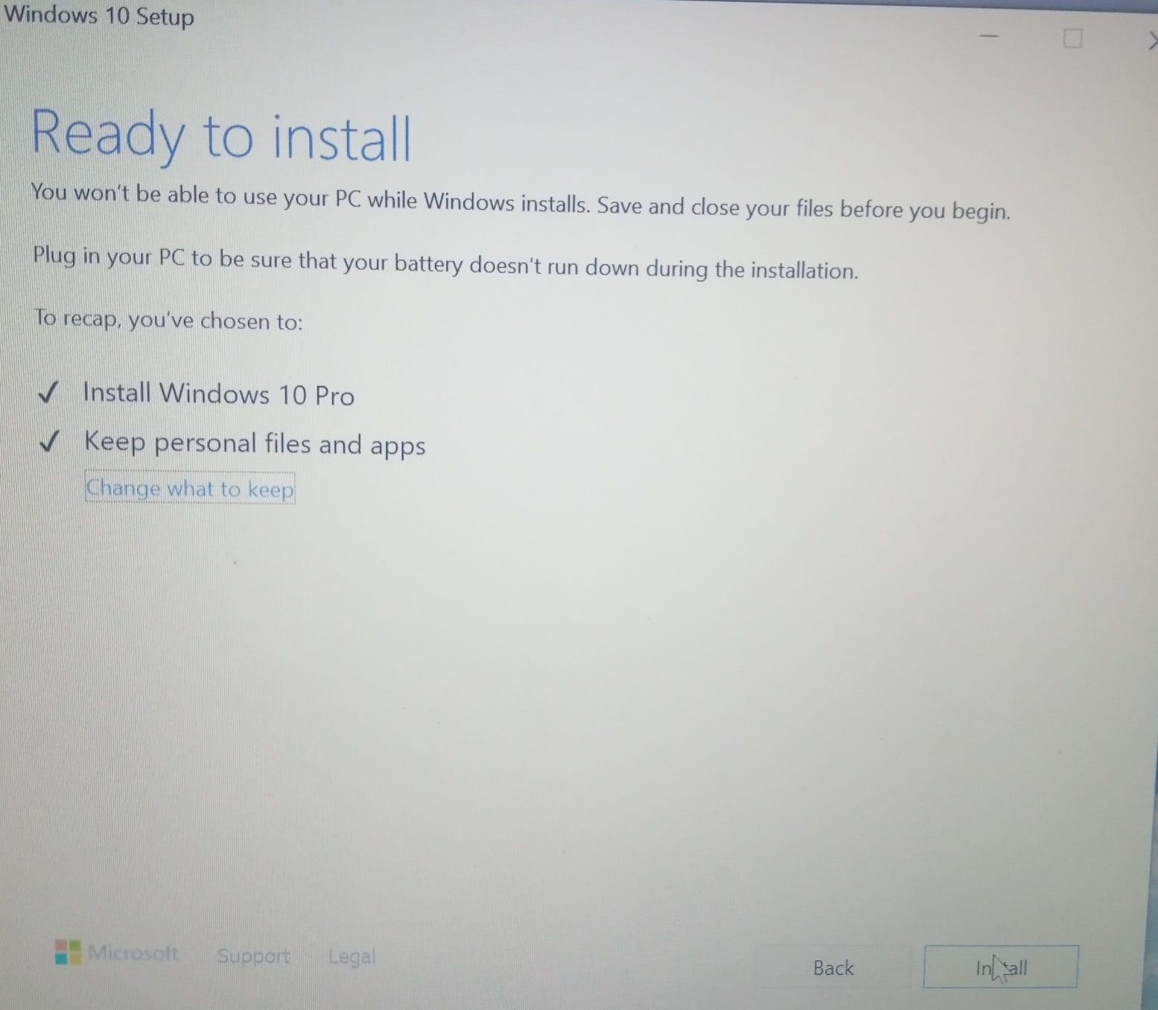

* + The screen will display your selected options:
  + Install Windows 10 Pro.
  + Keep personal files and apps (your files and programs will remain intact).
  + When you're ready, click "Install" to continue. Ensure your PC is plugged in and you've backed up any important data.

# STEP # 4

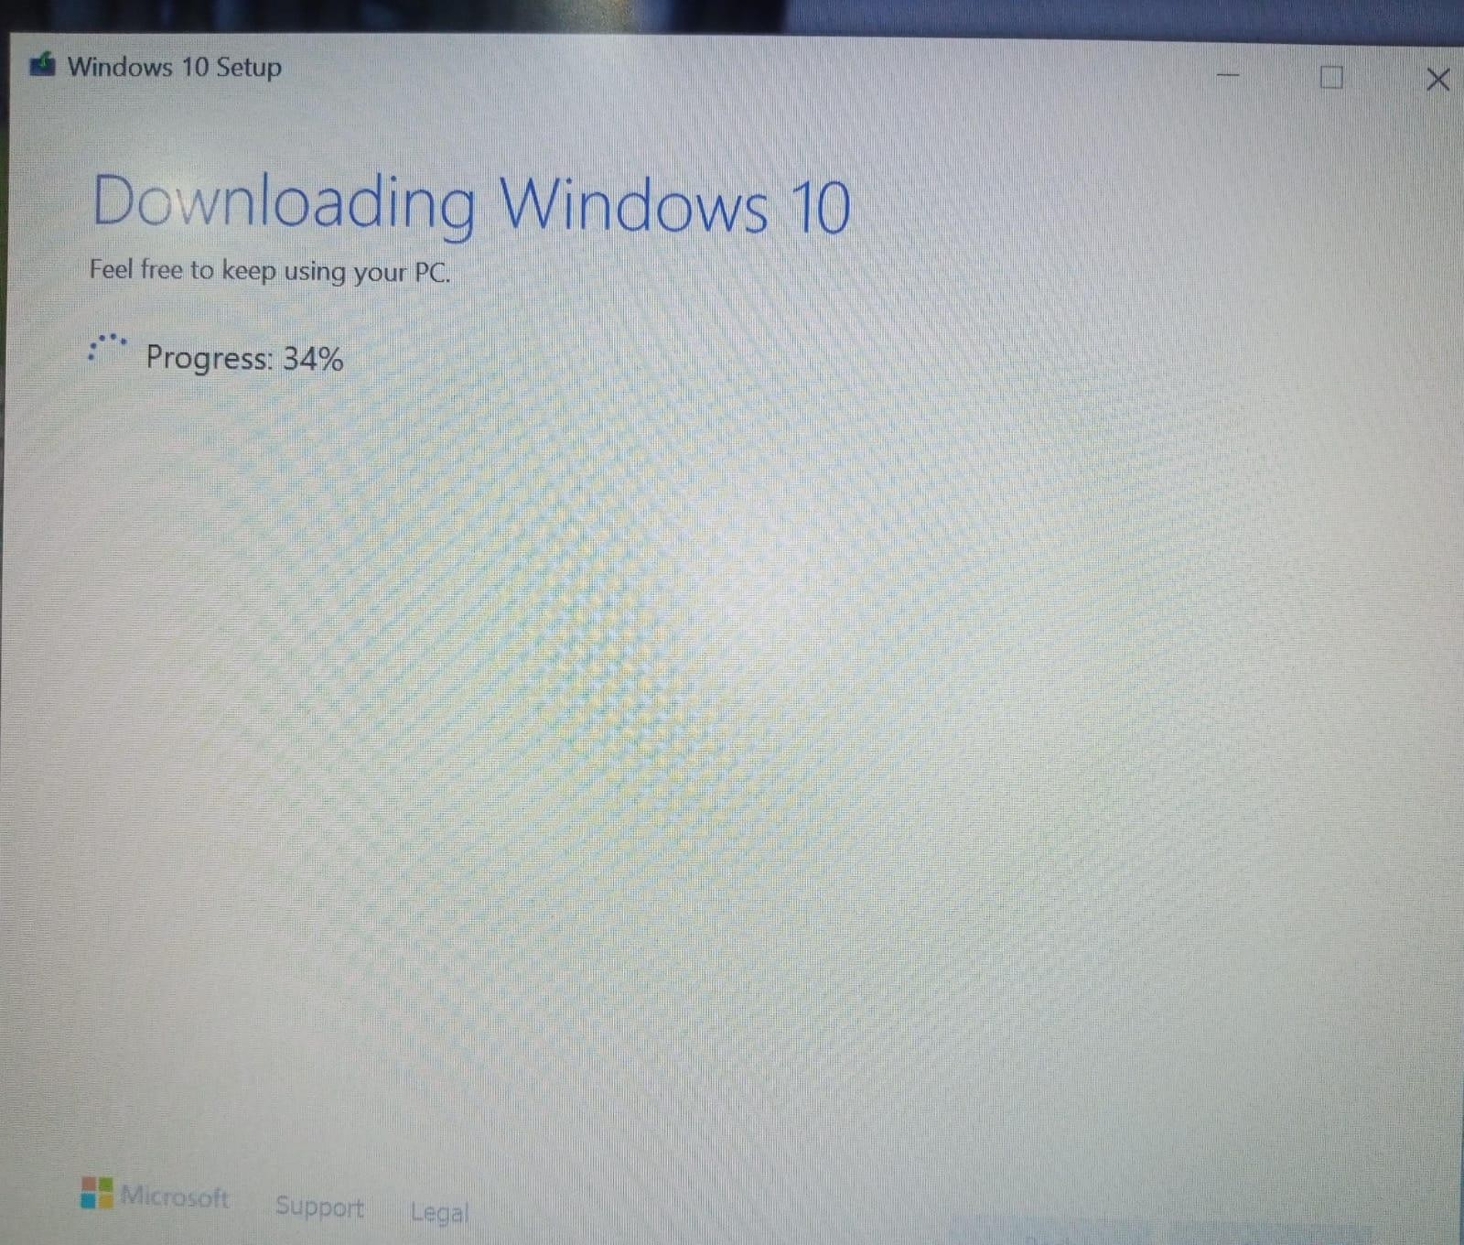

* + You can keep using your PC during the download, though your internet connection speed may affect performance.
  + After the download finishes, the installation will proceed automatically.